CIS581: Computer Vision and Computational Photography

Project 3A: Image Stitching

**Group 9**

Ang Li

Da Kuang

Jiaxiao Cai

This report aims to show the intermediate results of our projects.

Figure 1 to Figure 6 show the results of corner detection and adaptive non-maximum suppression of the assigned pictures.

|  |  |
| --- | --- |
| Figure 1 Corner Detection of Left Image | Figure 2 ANMS of Left Image |
| Figure 3 Corner Detection of Middle Image | Figure 4 ANMS of Middle Image |
| Figure 5 Corner Detection of Right Image | Figure 6 ANMS of Right Image |

Figure 7 to Figure 12 show the results of corner detection and adaptive non-maximum suppression of our own pictures.

|  |  |
| --- | --- |
| /var/folders/p4/sf9qxb0j2q55r81rwzsh4z1h0000gn/T/com.microsoft.Word/Content.MSO/3455645F.tmp  Figure 7 Corner Detection of Left Image of Towne Hall | /var/folders/p4/sf9qxb0j2q55r81rwzsh4z1h0000gn/T/com.microsoft.Word/Content.MSO/BA52CCC5.tmp  Figure 8 ANMS of Left Image of Towne Hall |
| /var/folders/p4/sf9qxb0j2q55r81rwzsh4z1h0000gn/T/com.microsoft.Word/Content.MSO/4071601B.tmp  Figure 9 Corner Detection of Middle Image of Towne Hall | /var/folders/p4/sf9qxb0j2q55r81rwzsh4z1h0000gn/T/com.microsoft.Word/Content.MSO/BC638BE1.tmp  Figure 10 ANMS of Middle Image of Towne Hall |
| /var/folders/p4/sf9qxb0j2q55r81rwzsh4z1h0000gn/T/com.microsoft.Word/Content.MSO/76B2B159.tmp  Figure 11 Corner Detection of Right Image of Towne Hall | /var/folders/p4/sf9qxb0j2q55r81rwzsh4z1h0000gn/T/com.microsoft.Word/Content.MSO/5E4475CF.tmp  Figure 12 ANMS of Right Image of Towne Hall |

Figure 13-17 show the RANSAC and Frame Mosaicing results of the assigned pictures.

|  |
| --- |
|  |
|  |
|  |
|  |

Figure 13 1st Frame of RANSAC of the Assigned Pictures

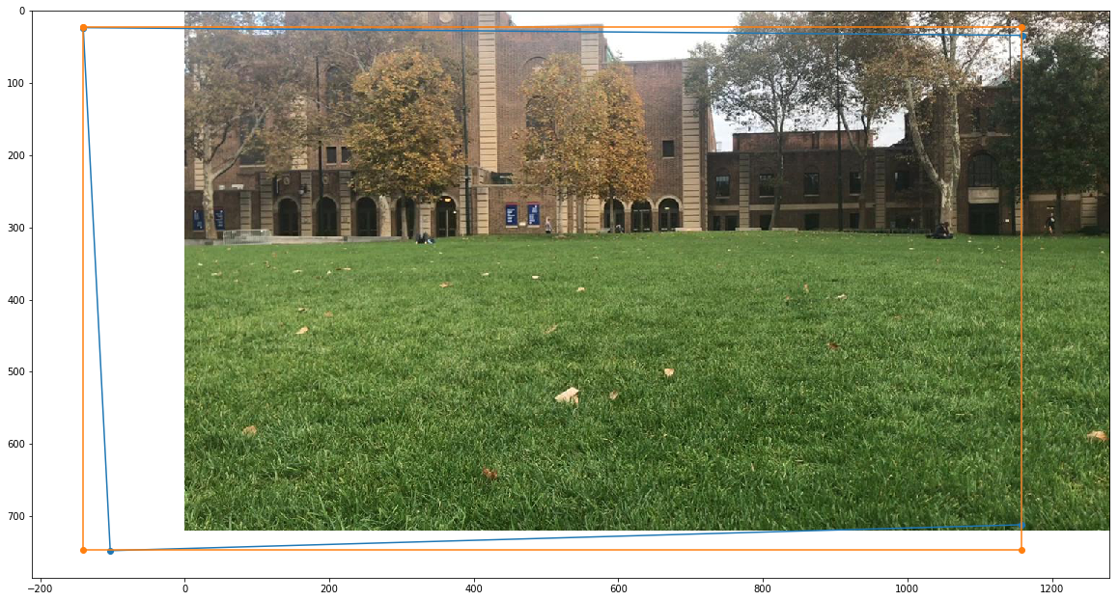

Figure 14 2nd Frame of Frame Mosaicing of the Assigned Pictures

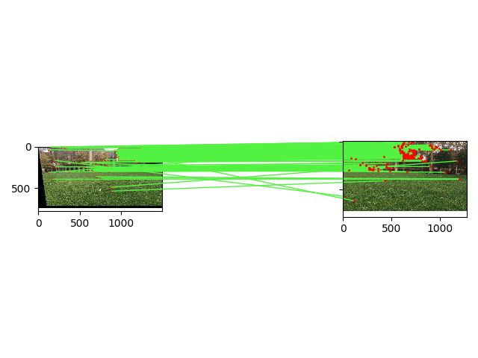

Figure 15 3rd Frame of Frame Mosaicing of the Assigned Pictures

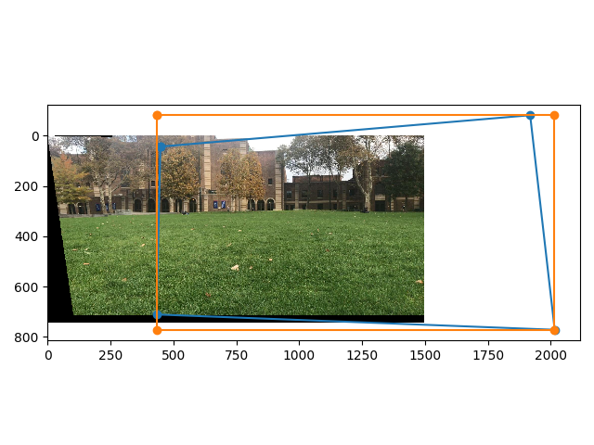

Figure 16 4th Frame of Frame Mosaicing of the Assigned Pictures

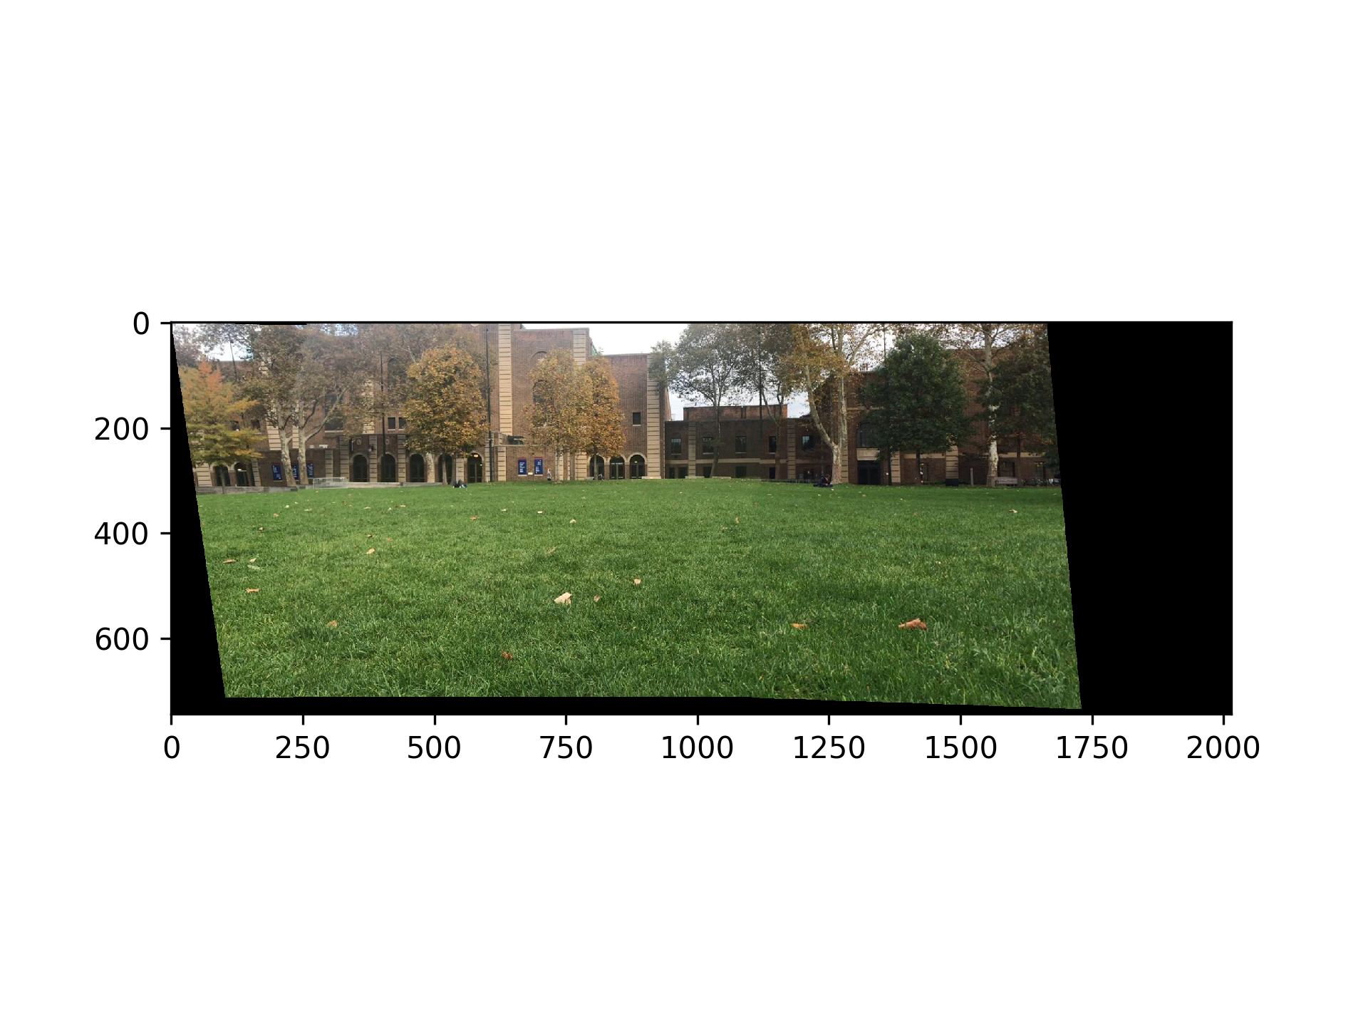

Figure 17 5th Frame of Frame Mosaicing of the Assigned Pictures

Figure 18-22 show the RANSAC and Frame Mosaicing results of our picture.

|  |
| --- |
|  |
|  |
|  |

Figure 18 1st Frame of RANSAC of Our Picture

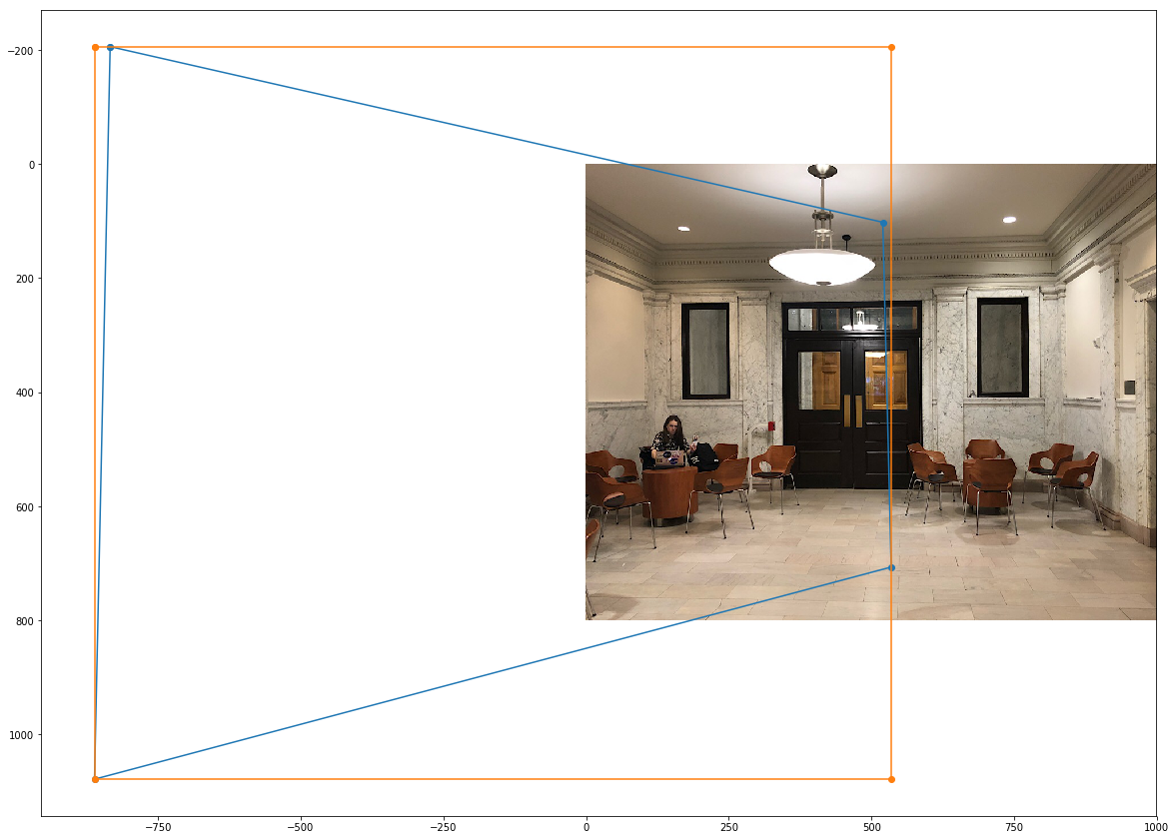

Figure 19 2nd Frame of Frame Mosaicing of Our Picture

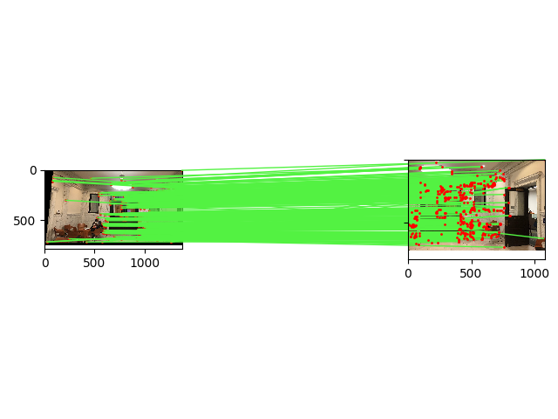

Figure 20 3rd Frame of Frame Mosaicing of Our Picture

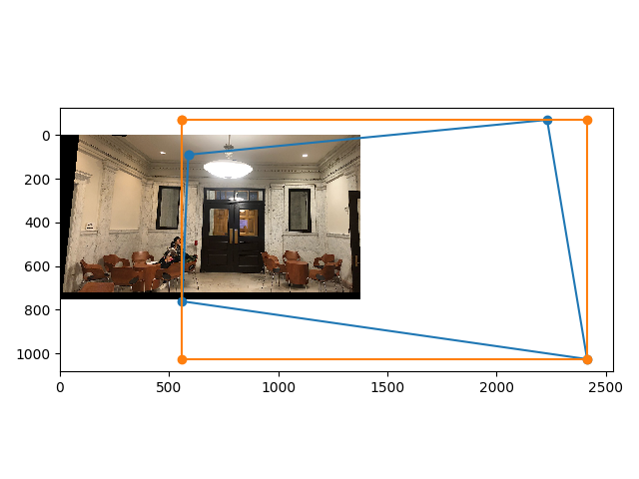

Figure 21 4th Frame of Frame Mosaicing of Our Picture

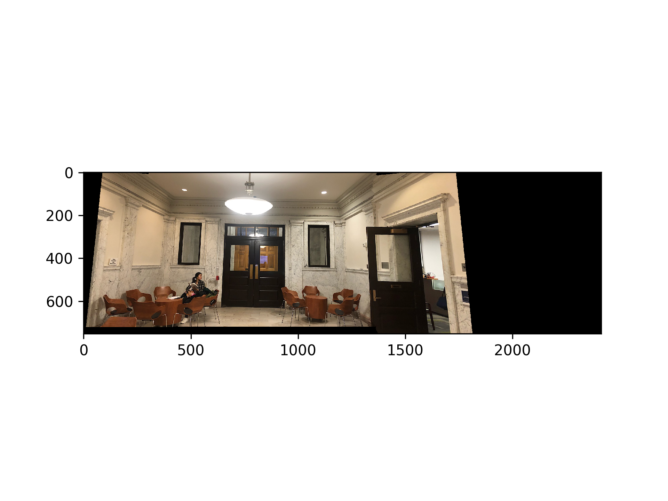

Figure 22 5th Frame of Frame Mosaicing of Our Picture